**Mr. Aditya Shetkar 1st February, 2023**

305,

Navdipti Apartment near Bhavika School

Kharegaon, Kalwa, Thane,

Thane

Pin Code - 400605

**CONFIRMATION LETTER**

Dear **Aditya**,

Consequent to the review of your performance during **28th July, 2022 to January 2023** have the pleasure in informing you that your services are being confirmed as **"Trainee Engineer"** with effect from **1st February, 2023**.

**Kindly note that your compensation is personal confidential information of the company. Any discussion or disclosure of your compensation with anybody other than your departmental head or HR will be considered as breach of agreement by you.**

**Performance linked incentives are paid annually if any.**

All the other terms and conditions as detailed in your appointment letter remain unchanged.

**For NeoSOFT Technologies**

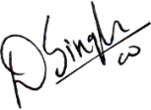

**Ms. Simran Singh**

**(AVP – Human Resources)**

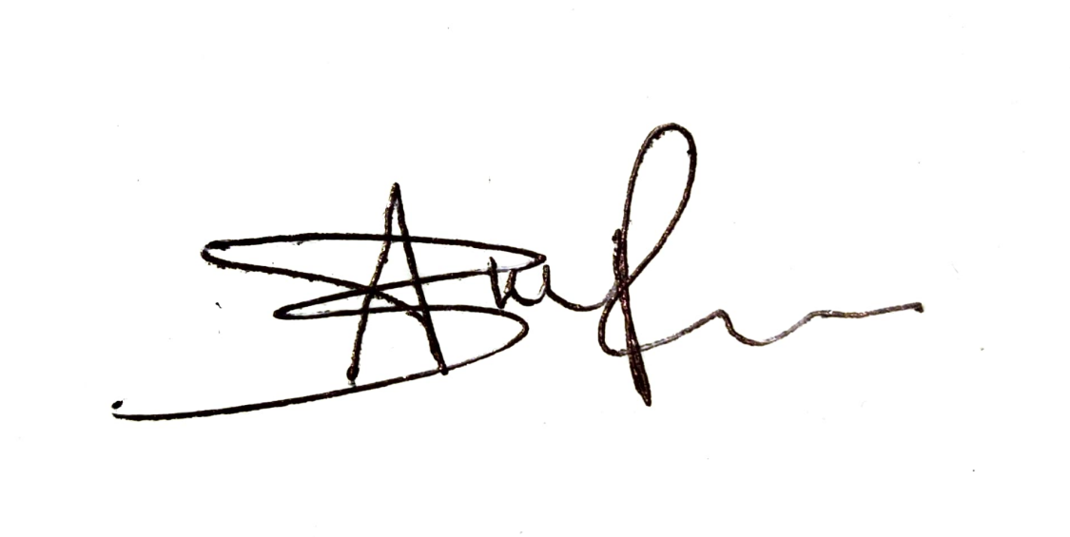

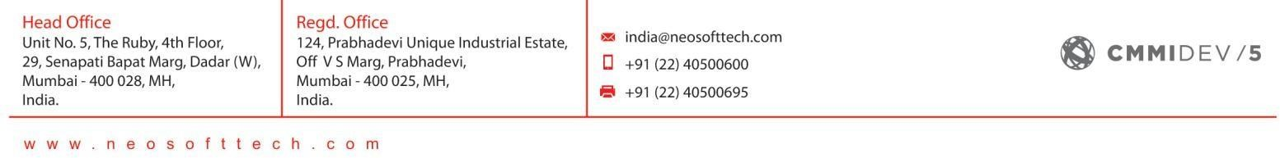

(#9286-8)